**Data Management Module**

**Project Template**

**Title ___________________________________________________**

1. **Data identification**
   1. Dataset 1
      1. Description
      2. Origin (Source of data, e.g. Sensors, measurement stations, public/restricted access dataset...)
      3. Collection (How data have been collected?)
      4. Update/Timing (e.g., one single time, each hour, each week, ...)
      5. Other Info
   2. Dataset 2
   3. …..
2. **Data lifecycle** (use Arass et al. “Data lifecycles analysis: towards intelligent cycle” as a reference)
   1. Needed phases of DLC (What phase is mandatory? What phase could be useful?)
      1. 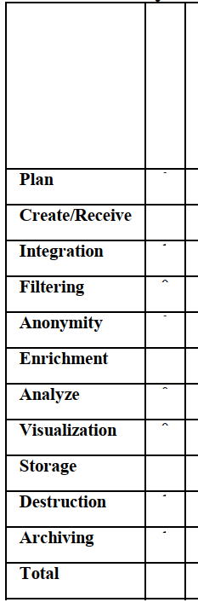
   2. Lifecycle selection (What is the best lifecycle for your needs? Why? Look at table 2 of the previously referred paper)
3. **Conceptual modelling of data** (using E-R model)
   1. List of Entities and relationships with attributes and keys
   2. E-R graphic representation
4. **On-Line Analytical Processing (OLAP) modelling**
   1. OLAP conceptual model of facts
   2. STAR schema of facts
   3. Some sample queries
5. **Conclusions**

Appendix: Table 2 of Arass et al. paper

